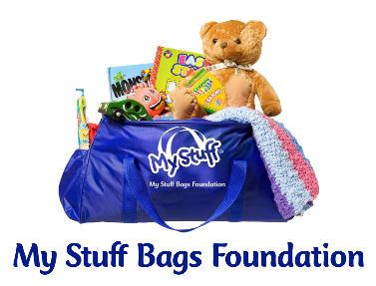

DONATION RECORD

We appreciate your contribution to the My Stuff Bags Foundation for abused, neglected, abandoned, and homeless children. Please fill out this record and enclose it with your donation so we can personally say “Thank you”!

DATE:__________________________

DONOR NAME:___________________________________________________________

ADDRESS:__________________________________________________________________

CITY: ____________________________________________________________________

STATE ________________________

ZIP: ______________

PHONE: ______________________

EMAIL: _______________________________________

Do you need a certificate for community service hours? Circle: Yes No
(Blanket donations only, 2 hours per blanket) If yes # of Blankets: _________

Comments:___________________________________________________________________

_____________________________________________________________________________

Rev. 3/24/2021

