GUIDELINES FOR TEAM BUILDING ACTIVITIES AND LARGE GROUP STUFFATHONS

My Stuff Bags has always been a “grass-roots” program, dependent upon the thousands of supporters across the country who generously donate new items for children, volunteer hours to pack My Stuff Bags and funding to help us deliver bags into the hands of children. These are, in fact, the 3 essentials which have helped us provide new necessities and hope to tens of thousands of lonely children across the nation: we call them “stuff,” “stuffers” and “green stuff”!

We truly appreciate that you are considering bringing your group of “stuffers” to volunteer time at the My Stuff Bags Foundation. Due, however, to the large volume of requests we receive, and the demand upon resources to host “employee team building” and other large group activities here at our Volunteer Center, we now find it necessary to respectfully request that these groups help us in more than one way, that is by either replacing some of the “stuff” necessary to fill the bags, or the “green stuff” required to get them to children.

All volunteer activities at the My Stuff Bags Foundation are by appointment only. Please call to schedule.

We are flexible and would be happy to discuss the guidelines below with you further.

DONATION GUIDELINES FOR LARGE GROUP ACTIVITIES AT MY STUFF BAGS FOUNDATION

Groups of 10 to 15 people
$25 donation per person, or 30 blankets or stuffed animals or toys (valued at approximately $10 each)

Groups of 16 to 25 people
$25 donation per person or 50 blankets or stuffed animals or toys (valued at approximately $10 each)

Groups of 26 to 35
$25 donation per person or 70 blankets or stuffed animals or toys (valued at approximately $10 each)

Groups of 36 to 50
$25 donation per person or 100 blankets, stuffed animals or toys (valued at approximately $10 each)

Groups of 50 to 60
$25 donation per person or 120 blankets or stuffed animals or toys (valued at approximately $10 each)

We are happy to consider combinations of cash and inventory donations from your group. Call Gail Rosenberg at the My Stuff Bags Foundation 818-865-3860.

Please Note: All children’s inventory donations must be new, non-denominational, non-violent and must fit in a mid-sized duffel bag. Blankets can be handmade or purchased (there are also no-sew fleece blanket instructions on our web site.)

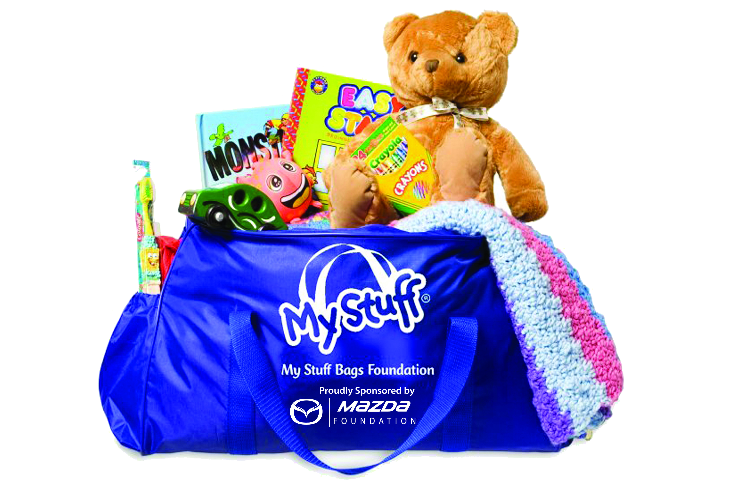

Contact Information:
Gail Rosenberg, Administrative Assistant
Phone: 818.865.3860 --- Email: grosenberg@mystuffbags.org

www.mystuffbags.org

