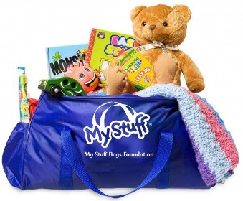

GUIDELINES FOR SCHOOLS, CAMPS and UNDER AGE 18 GROUPS
We’re thrilled you’re considering bringing your group of “stuffers” to volunteer at the My Stuff Bags Foundation. Due to the large volume of requests we receive, and the demand upon resources to host group activities at our Volunteer Center, we find it necessary to respectfully request that visiting groups also help us by replacing some of the “stuff” necessary to fill My Stuff Bags or help with funding to ship them, see guidelines below.
A Stuff-a-thon in action!
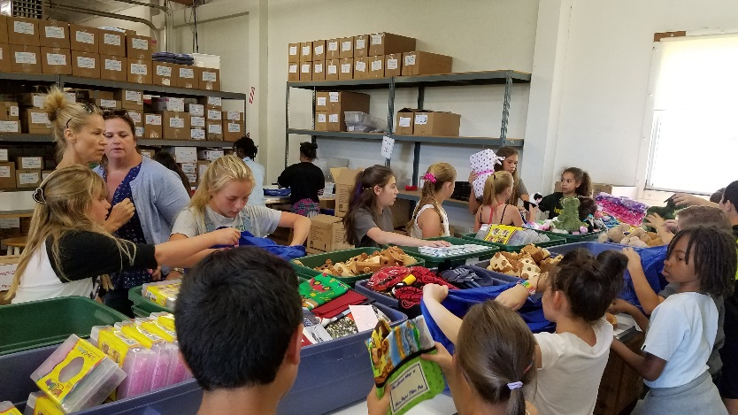
DONATION GUIDELINES FOR GROUP ACTIVITIES AT MY STUFF BAGS FOUNDATION
Each child is asked to bring at least one of the following new items: a child sized blanket, medium sized stuffed animal or toy (valued at approximately $10 each) or a $10 donation.
We are flexible and would be happy to discuss the guidelines with you further.
Some other activities to consider include:
Host a collection drive with your class, school, camp or club
Make no-sew fleece blankets as a group activity
(See www.mystuffbags.org for collection suggestions and blanket making instructions)
Please Note: All inventory donations must be new, non-denominational, non-violent and must fit in a mid-sized duffel bag.

It’s fun to make these no-sew blankets! Girl Scout Troop #60991 collected so much “stuff”!
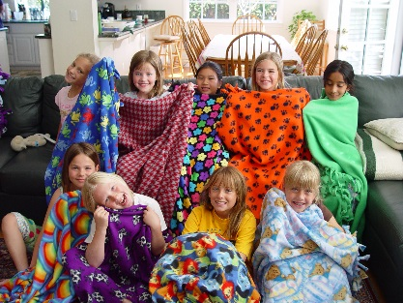
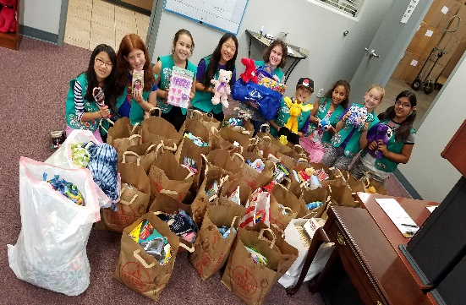

All volunteer activities at the My Stuff Bags Foundation are by appointment only.
My Stuff Bags Foundation
5347 Sterling Center Drive, Westlake Village, CA 91361

Contact: Gail Rosenberg, Program & Volunteer Relations Coordinator
Phone: 818.865.3860 --- Email: grosenberg@mystuffbags.org

